[http://www.washingtonpost.com/local/children-suffer-from-growing-economic-inequality-among-families-since-recession/2013/09/10/793423ae-1a4f-11e3-82ef-a059e54c49d0\_story.html](http://www.washingtonpost.com/local/children-suffer-from-growing-economic-inequality-among-families-since-recession/2013/09/10/793423ae-1a4f-11e3-82ef-a059e54c49d0_story.html" \t "_blank)

**Who U.S.-born children are living with**

**A study by Ohio State University's Department of Sociology found that more white and Asian children live among dual-income households than black and hispanic children, who have a higher percentage living with grandparents. Almost one-quarter of black children live with their single, never-married mother.** [**Read related article.**](http://www.washingtonpost.com/local/children-suffer-from-growing-economic-inequality-among-families-since-recession/2013/09/10/793423ae-1a4f-11e3-82ef-a059e54c49d0_story.html)

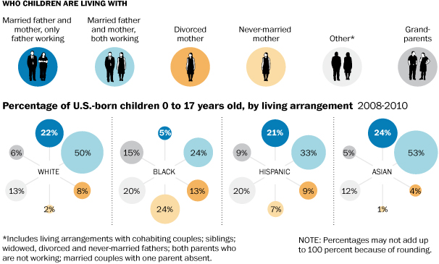

Source: ”Divergent Paths of American Families” report, Department of Sociology at Ohio State University. Cristina Rivero/The Washington Post. Published on September 11, 2013, 12:01 a.m.

# Children suffer from growing economic inequality among families since recession

### By [Brigid Schulte](http://www.washingtonpost.com/brigid-schulte/2011/02/25/ABFkyCJ_page.html), Published: September 11, 2013 [E-mail the writer](mailto:brigid.schulte@washpost.com?subject=Reader%20feedback%20for%20%27Children%20suffer%20from%20growing%20economic%20inequality%20among%20families%20since%20recession%27)

American families are becoming increasingly polarized along race, class and educational lines, according to a new report released Wednesday, a sign of growing economic inequality that was exacerbated by the Great Recession.

The report, “[Divergent Paths of American Families](http://researchnews.osu.edu/archive/divergentpath.htm),” found a widening gap in recent years between families that are white, educated or economically secure and minority families, those headed by someone with a high school degree or less, and poor families.

Who U.S.-born children are living with

## [Fertility rates in U.S. appear to be leveling off](http://www.washingtonpost.com/local/fertility-rates-in-us-appear-to-be-leveling-off/2013/09/05/507444a6-165f-11e3-be6e-dc6ae8a5b3a8_story.html)

Carol Morello SEP 6, 2013

After six years of steep decline, birth numbers are stabilizing, government statistics show.

The concern, report authors say, is not that American families are becoming diverse. Advances in civil rights and women’s economic independence have opened up individual choice and transformed the American family in the past 50 years. The concern, they wrote, is that the divisions fall along race, class and educational lines and that they are accelerating.

“I was struck by how strong the divide has become in terms of education,” said report author Zhenchao Qian, a sociologist at Ohio State University. “The gap between the haves and the have-nots, and the children who excel and who lag behind, grew larger than ever in the 2000s.”

Increasingly “Balkanized” American families, Qian said, set the children born into them on divergent paths to greater success or disadvantage based to a larger degree than before on the educational level of their parents.

Qian and his associates analyzed census data from 2000, 2008 and 2010 to study the effects of the Great Recession on families and found that men and women with high levels of education were more likely to be married. They were more likely to stay married. There were fewer instances of cohabitation or divorce than those with lower levels of education. And their children were much less likely to live in poverty and instead more likely to benefit from family stability, increased parent time and higher economic resources.

The report also found the Great Recession probably exacerbated the trend toward delaying marriage and the continued rise of people staying single.

Family historian Stephanie Coontz said that there never has been a “typical” American family. In the 18th and 19th centuries, child labor, slavery and economic inequality made for very diverse families. But family situations started to converge in the 20th century, she said, with the passage of child labor laws, progressive educational policies and a booming economy with real wages that increased every year in the 1950s.

“What we’re seeing today is two divergences,” Coontz said. “On the one hand, people have more options than they used to. Women have a choice not to enter a bad marriage or to get out of it. Divorce is no longer stigmatized. That diversity is here to stay. But then there’s this unpleasant diversity that’s not a matter of free choice but constrained options.”

This second divergence is a result “of widening economic inequality that, unless we decide as a society to invest in livable-wage jobs and a truly egalitarian educational system, will only get worse,” Coontz said.

In the report, Qian also found large divides between U.S.-born and immigrant families, with an overwhelming majority of immigrants, regardless of educational level, embracing marriage; eschewing divorce, cohabitation and remarriage after divorce; and more children living in traditional male-breadwinner, female-homemaker types of families.

U.S.-born couples, in contrast, were much more likely to marry, divorce and remarry. The report found that such “serial marriage” increased rapidly between 1980 and 2010, particularly among those with a high school degree or less.

Half of all U.S.-born white children younger than 17 lived in families with married parents, both of whom worked in 2008 to 2010, as did 33 percent of all U.S.-born Hispanic and 53 percent of U.S.-born Asian children. Nearly one-quarter of U.S.-born white, Hispanic and Asian children lived in more traditional breadwinner-homemaker families, fewer than among their immigrant counterparts.

The report found the biggest discrepancy for U.S.-born African American children. Twenty-four percent lived in families with married, dual-income parents — about half the percentage of children of other racial and ethnic groups. Thirty-seven percent lived in families headed by never-married or previously married single mothers, in contrast to 10 percent of US.-born white children, 16 percent of U.S.-born Hispanic children and 5 percent of U.S.-born Asian children. And 15 percent of U.S.-born African American children, higher than any other racial or ethnic group, lived with grandparents.

In the report, Qian found that, for all U.S.-born children, living arrangement was a strong indicator of poverty. Four percent of U.S.-born children living in dual-income families were poor in 2010, followed by 14 percent in traditional families, while nearly 60 percent of the children living with single, never-married mothers were.

“The vast majority of people want to have long-term, stable relationships,” said Philip Cohen, a University of Maryland sociologist who studies family inequality. “The fact that rich people are becoming more able to do that than poor people is just another indicator of the unequal society we live in.”